Prusa RepRap software/electronics setup for RAMP 1.4

# Download Arduino 0.22

Use version 0.22 of the Arduino Software. The 1.0 version has issues with uploading sketches to the Arduino Mega 2560 board when the RAMPS v1.4 board is connected.

* <http://arduino.googlecode.com/files/arduino-0022.zip>

# Unzip Ardruino 0.22 to c:\Ardruino

1. Right click the arduino-0022.zip file and click “Extract All…”
2. 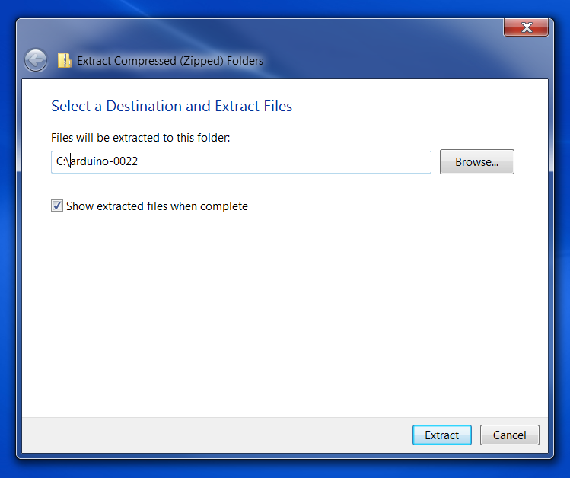Set the location to C:\Arduino-0022 and click extract

# Install the Driver for Arduino

To be able to upload sketches to the Arduino device, a driver must be installed on your system

1. With the RAMPS 1.4 board not connected to the Arduino Mega 2560 board, attach the USB cable to the Arduino and the computer.

Windows will detect the device and start an automatic device driver installation

1. When windows prompts to search for a driver or browse for the driver path, select Browse for a path
2. In the path browser, navigate to the c:\arduino\driver directory and click “OK”

Windows will install the driver, in about 5-10 minutes the driver will be installed.

1. TBD: ?Configure com port speed?

# Test Arduino with blink.pde

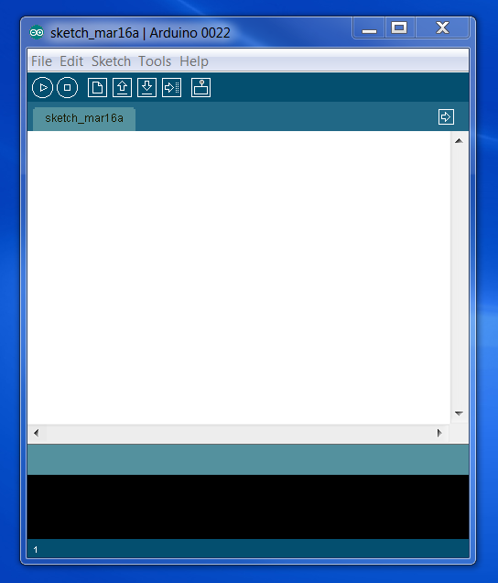Time to check if your Arduino board functions.

1. Execute c:\arduin-022\arduino.exe
2. Open c:\arduino-022\examples\1.Basics\Blink\Blink.pde
   1. 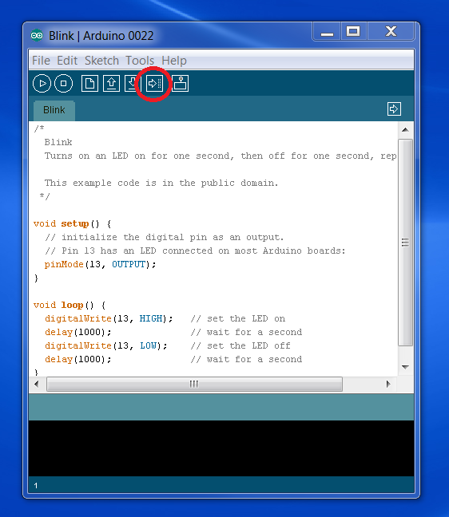File->Open…
   2. Browse and select c:\arduino-022\examples\1.Basics\Blink\Blink.pde
      1. A new Arduino software window will open with the Blink.pde code
   3. Close the old empty window. Issues have been seen when leaving this window open.
3. Click upload button

In less than a minute, the code will compile and upload to the Arduino. If the upload hangs and reports a timeout, you have a communication issue. This issue is routinely seen if the RAMPS 1.4 board is connected and Arduino Software 1.0 is used.

The LEDs circled in Purple will blink while uploading. After upload the LED circled in Red will blink.

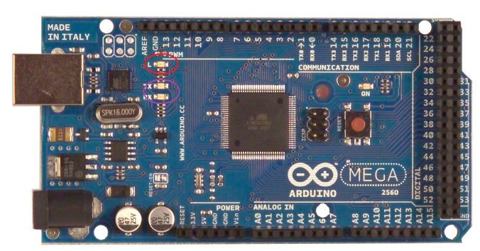

1. Unplug the USB cable from the computer

Every Time the Arduino board powers on it reloads the last loaded Sketch.

# Download Marlin firmware to Arduino

1. Plugin the RAMPS 1.4 board to the Arduino MEGA 2560 Board
2. Download the Marlin Firmware
   1. <https://github.com/ErikZalm/Marlin/downloads>
3. Unzip Marlin to c:\Marlin
4. Open marlin.pde in Arduino
5. Edit configuration.h
   1. Comment out #define BAUDRATE 250000

Some systems have issues with this BAUDRATE

* 1. Uncomment #define BAUDRATE 115200
  2. Set #define MOTHERBOARD 33
  3. Comment Out #define PREVENT_DANGEROUS_EXTRUDE

For testing purposes only, this will be re-enabled later.

* 1. Set bool X_ENDSTOP_INVERTING=false
  2. Set bool Y_ENDSTOP_INVERTING=false
  3. Set bool Z_ENDSTOP_INVERTING=false
  4. Set #define INVERT_E0_DIR= true
  5. Set #define INVERT_Z_DIR= false
  6. Set #define min_software_endstops false
  7. Set default_axis_steps_per_unit (80,80,2560,500)

The 500 steps for the extruder will need to be varied due to variences in the hobbed bolt.

* 1. Comment out #define SDSUPPORT

1. Upload to Arduino
2. Open Serial Monitor
   1. Tools->Serial Monitor

Verify the communication with Arduino Controller. The Marlin firmware header should be displayed in the Serial Monitor

1. Close Serial Monitor
2. Exit Arduino

# Test Motor Movement and verify calibration

1. Download Repetier-Host
   1. <https://github.com/repetier/Repetier-Host/downloads>
2. Download Python 2.7.2
   1. <http://python.org/download/releases/2.7.2/>

Do not use the 3.x version of Python, Skeinforge will not function and Repetier-Host will throw warning dialogs.

1. Install Python 2.7.2
2. Open Repetier
3. Connect to printer
4. Jog x axis
5. Jog y axis
6. Jog z axis
7. Jog extruder

# Test EndStops

Testing the End Stops can be accomplished by Pressing the Home button in Repetier and hoping they work and your reflexes are fast enough to disable the power when the endstops don’t work. Or you can follow the steps below. The disadvantage is you will need 3 jumpers to bridge the MAX Endstops for each axis.

1. Connect Jumpers to MAX EndStops of each axis

If this is not done the axis will not move in the positive direction while testing.

1. Execute Arduino.exe
2. Open Marlin.pde
3. Edit configuration_adv.h
   1. Comment out #define ENDSTOPS_FOR_HOMING_ONLY
4. Upload to Arduino
5. Launch Repetier
6. Push X endstop and Jog x axis toward home
   1. No movement should occur
7. Push Y endstop and Jog y axis toward home
   1. No movement should occur
8. Push Z endstop and Jog z axis toward home
   1. No movement should occur

# Dry Run to determine if current levels should be raised

1. Configure Repetier internal slic3r
2. Open Pursa plate 1 and convert to gcode
3. Edit gcode, comment out temperature heat up
4. Run job
5. Cancel and move X to 100, measure calibration
6. Cancel and move Y to 100, measure calibration
7. Cancel and move Z to 10, measure calibration

# Prepare for first printing

1. Download Skeinforge
2. Install Skeinforge
3. Open Arduino 0.22
4. Open marlin.pde
5. Edit configuration.h
   1. Disable negative moves
   2. Uncomment disable heatless extrude
   3. Uncomment #define ENDSTOPS_FOR_HOMING_ONLY
6. Upload to reprap
7. Ready to print